Not for release before March 10, 2020- 8 am Central European Time
News Release
HP Indigo Unveils Industry-Leading Labels and Packaging Portfolio
Next-gen HP Indigo V12 Digital Press, as fast as analog, redefines digital label printing

News highlights

- Unveiling the HP Indigo V12 Digital Press for labels. The first HP Indigo based on next-gen LEP^{X} architecture, the press prints as fast as analog and creates new opportunities for label production with HP Indigo’s renowned print quality, ink range, and application versatility.
- Spot Master, HP Indigo’s next-generation color automation technology, introduces the industry’s fastest time to brand colors with superior color quality and uniformity.
- HP Indigo 6K and HP Indigo 8K Digital Presses feature wider application possibilities, delivering more jobs per day using advanced color and workflow automation capabilities.
- B2 sheetfed HP Indigo 35K and roll-to-sheet B1 HP Indigo 90K presses for folding cartons serve verticals such as health and personal care, plastic cards and high-end folding carton markets with increased productivity, wider application range and extended color capabilities.
- HP Indigo 25K Digital Press provides improved total cost of ownership to help labels and flexible packaging converters grow profitably, delivering on-demand flexible packaging.
- HP PrintOS^{X} and the HP Production Pro for Indigo Labels and Packaging Print Server allow converters to realize the vision of the print factory of the future, processing more jobs every day with minimal operator touchpoints.

PALO ALTO, Calif., March 10, 2020 — HP Inc. (NYSE: HPQ) today announced an all-new drupa portfolio for HP Indigo digital labels and packaging designed to accelerate the digital print transformation. HP Indigo offers converters the industry’s widest portfolio of presses, along with new color and workflow automation solutions, to efficiently deliver diverse, on-demand print orders with low waste.
In a major step toward extending analog-to-digital conversion, HP announced the, HP Indigo V12 Digital Press, the first HP Indigo built on next-generation HP Indigo LEP^{X} architecture. The first of Indigo’s Series 6 platform, the narrow-web label press provides Indigo’s renowned quality and versatility at significantly higher speeds. As a result, the HP Indigo V12 can print as fast as analog with greater production agility, redefining digital label printing.¹
The drupa portfolio also introduces the new narrow-web HP Indigo 6K and HP Indigo 8K digital presses for labels, the HP Indigo 25K for flexible packaging and labels, and sheetfed HP Indigo 35K and roll-to- B1 sheet HP Indigo 90K for folding cartons. Value packs with various upgrade options will allow the existing customer base to benefit from new features and capabilities.
“The digital labels and packaging market is growing and evolving as converters move to support market needs for on-demand production, SKU diversification, customization and printing with reduced waste,” said Alon Bar-Shany, general manager, HP Indigo. “Labels and packaging converters using HP Indigo are growing their Indigo volume four times faster than the market and are consistently generating new opportunities. The new labels and packaging portfolio unveiled today is a blueprint for customers to create a digital print factory so they can stay ahead of the curve and deliver a wider range of jobs faster, with less labor, all while keeping the environment top of mind.”
Since drupa 2016, more than 1000 HP Indigo labels and packaging presses have been installed at converters worldwide.²

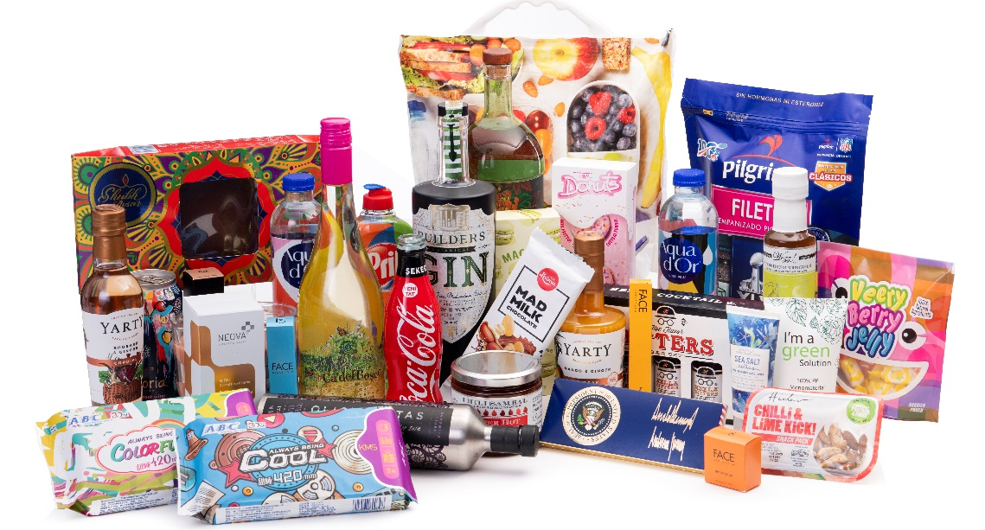

Advanced workflow and color automation tools
A new color automation solution, Spot Master, will enable converters to reach brand colors within minutes, making it the industry’s fastest time-to-color solution.³ Spot Master enables converters to deliver high color consistency and uniformity across the entire print frame using a new patented algorithm for fast and accurate color matching, ensuring every package looks the same no matter when or where it was printed. Spot Master will be available for the HP Indigo 35K, HP Indigo 25K, HP Indigo 6K and HP Indigo 8K presses.
Brand Beat, a new application offered in HP PrintOS^{X}, delivers real time color reports directly to converters and brands.
PrintOS Production Pro for Indigo Labels and Packaging, featuring HP Indigo’s fastest HP Indigo Raster Image Processor (RIP), is seamlessly integrated with the new Esko Automation Engine for HP Indigo, allowing converters to process more jobs per day. HP PrintOS^{X} unites the cloud platform applications with AI-driven service and support infrastructure to help customers get the most out of their press investment. With its suite of tools and applications, customers can start building the digital Print Factory of the Future and reach operational excellence by automating production and minimizing operator touchpoints.
Disrupting the labels market
The HP Indigo labels portfolio is the industry’s most versatile array of label presses for any size converter or label volume to run a digital label factory.
The HP Indigo V12 Digital Press is poised to disrupt the label market ecosystem by making significant production volumes a reality for operators with HP Indigo’s well-known quality and flexibility. Key benefits to be offered by the HP Indigo V12 Digital Press include:
- Print up to six colors at 120 linear meters per minute (400 f/pm), using six inline imaging engines running simultaneously. Produce up to 130,000 linear meters per day with one operator.
- New high definition (HD) imaging: HD Imaging System on press offers native to 1600 dpi resolution. .
- Up to 12-colors on press. Change inks on the fly and create any combination of colors.
- Print on digital label printing industry’s largest range of substrates, from 12 micron film to 450 micron (18pt) board. Support pressure-sensitive, sleeves, flexible packaging, tubes, IMLs and more.⁴
- One-pass, nonstop high-speed finishing capabilities to be provided by AB Graphic International.

Additionally, the HP Indigo 6K Digital Press is the new model of the highly successful, high-versatility HP Indigo 6000 series. The press can deliver more applications using higher opacity white for shrink sleeves, new inks including silver, fluorescents, invisible red and green for brand protection applications and new varnishes from leading partners for higher durability. The HP Indigo 8K offers increased productivity, reduced waste and easier transitioning between media types and jobs. High-capacity label production and flexible packaging on the new mid-web HP Indigo 25K Digital Press are supported with a new slitter for labels, making it easier to diversify into new and lucrative applications.
With HP Indigo Secure and partner solutions, converters can provide brand protection solutions using special inks, anti-counterfeiting marks, micro-text fonts and protected track and trace solutions. Digital embellishment solutions from HP Indigo and partners offer ways to stand out, including the inline KURZ DM-JETLINER® digital metallization solution, HP Indigo ElectroInk Silver for metalizing the color gamut, and HP Indigo GEM, a digital print-and-embellish, one-pass solution integrated with the HP Indigo 6K Digital Press.

Capturing opportunities with folding cartons
The drupa 2020 portfolio significantly extends HP Indigo folding carton capabilities, offering enhanced productivity, wider application range and expanded color capabilities. The portfolio includes the new sheetfed B2 HP Indigo 35K for high-value folding cartons, the new sheetfed B2 HP Indigo 15K for mixed commercial print and packaging production and the new B1 HP Indigo 90K roll-to-sheet solution with an inline water-based/UV coater and sheeter.

Building on the experience of over 100 folding carton press installations worldwide, the HP Indigo 35K introduces significant enhancements:
- Fastest time to color with Spot Master color automation.
- Faster job changeover with drawers, pallet feeder and proof-while-print capabilities.⁵
- Printing on thinner substrates from 150 microns to capture applications such as rigid boxes.
- New HD printing with 1600 dpi for enhanced print quality.
- New HP Indigo ElectroInk Premium White for higher opacity.
- New ElectroInk Invisible Yellow, track0-and-trace solutions and security elements for multi-layered brand protection applications on one press, in one pass.
- TRESU iCoat II, integrated with the HP Indigo 35K, delivers offset-quality for overprint varnish and coating applications using industry-standard UV or water-based varnish in a single production pass now optimized for high accuracy varnish registration at full speed.

Meet the growing demand for sustainable flexible packaging
HP Indigo customers created the digital flexible packaging market with the capability to offer on-demand and sustainable flexible packaging. The new HP Indigo 25K Digital Press is designed to help converters meet brand needs with an even more attractive total cost of ownership, a wider media range to deliver compostable and recyclable pouches and more choices to create a digital pouch factory. Advances to help converters harness production power include:
- Fastest time to color with Spot Master color automation.
- Optimized lamination solutions with the new SuperSimplex e800 laminator by Nordmeccanica. The 800 mm wide solventless laminator offers low waste and reduced energy consumption for on-demand pouch production. The field-proven Karlville Pack Ready thermal laminator and Karlvile KS-DSUP-400 pouch maker are optimized for shorter runs.
- Greater flexibility with two white ink stations.
- Higher productivity with frame expansion from 729 mm to 737 mm.
- Sustainability credentials include the Green Leaf mark and certification from TUV Austria’s “OK Compost” verifying HP Indigo ElectroInks can be used as printing inks for packaging and are recoverable through composting and biodegradation in accordance with leading standards.⁶ In addition, HP Indigo ElectroInks comply with leading food packaging regulations and are free of UV-reactive chemistries.⁷ All Indigo presses are manufactured carbon neutral.

Availability
The HP Indigo 6K, HP Indigo 8K, HP Indigo 25K, HP Indigo 35K, and HP Indigo 90K digital presses will be commercially available at drupa or by the end of 2020. The HP Indigo V12 will be demonstrated at drupa and is scheduled for commercial availability in 2022.
Visit the HP drupa 2020 online press kit for more information on today’s announcements and to follow HP’s drupa news.
About HP Inc.
HP Inc. (NYSE: HPQ) creates technology that makes life better for everyone, everywhere. Through our product and service portfolio of personal systems, printers and 3D printing solutions, we engineer experiences that amaze. More information about HP Inc. is available at www.hp.com.

- Compared to major printing competitors providing narrow-web solutions as of March 10, 2020.
- Based on HP internal data.
- According to HP Internal analysis of print solutions as well as customer validations. Enabled by Spot Master technology and the inline Xrite spectrophotometer.
- Compared to digital printing competitors providing narrow-web solutions as of March 10, 2020.
- Compared with the HP Indigo 30000 Digital Press.
- Certified for certain HP Indigo inks and up to specified limits.
- Printing on non-food-contact side, under well-defined conditions of use.

Vanessa Forbes, HP  vanessa.forbes@hp.com  www.hp.com/go/newsroom | Nina Gilbert, HP  nina@hp.com

